1. On the home page can you please help me set these boxes up so that they have spaces just like on the left side:

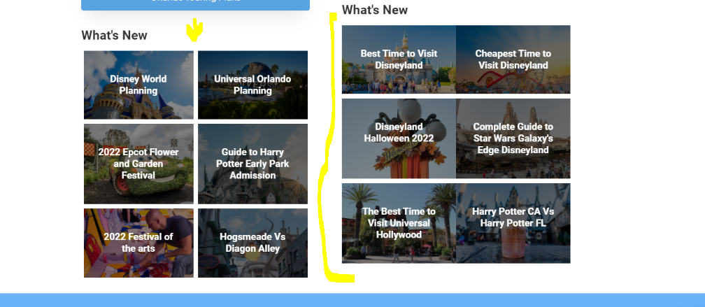

1. On the mobile version of the home page the about us pictures are cut off can we fix that?

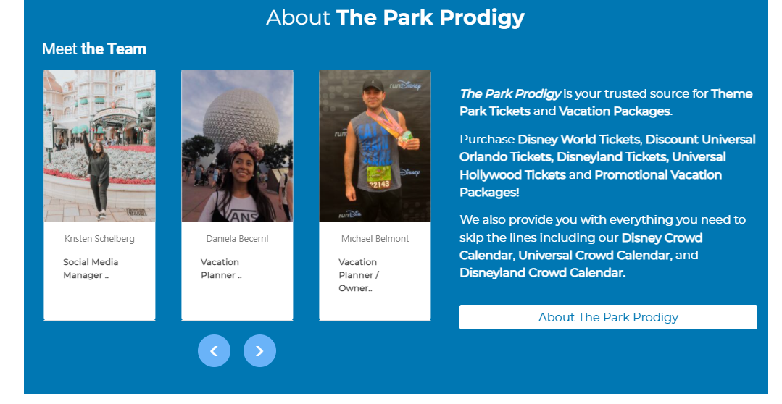

1. Can we fix the way that the Geine+ wording appears in this page: <https://theparkprodigy.com/tickets/disney-world-options/>

Next to the price we will need it to say __ - Day Disney World Base Ticket/ 3 Adult

What is happening is people are adding the Genie+ to the cart for 3 day tickets then buying 7 day tickets and asking for Genie+ so we need in writing how many days and people the Genie + is for

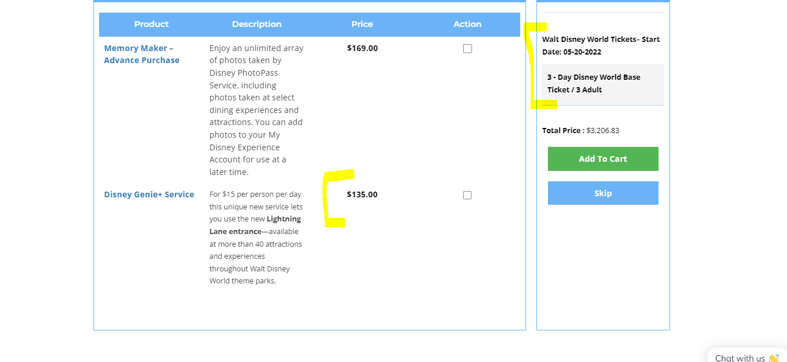

1. Please also make sure that we are pulling this wording into the cart page:

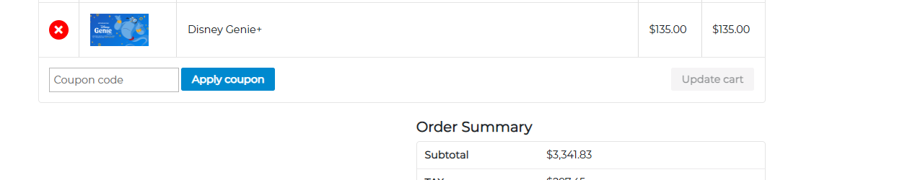

1. On the Universal Orlando section of the app can you please change these photos <https://theparkprodigy.com/testing/custom-daily-park-plans/>

Can you please replace them with the following:

Universal Studios: https://theparkprodigy.com/wp-content/uploads/2021/09/3-park.png

Islands of Adventure: <https://theparkprodigy.com/wp-content/uploads/2021/09/3-park-1.png>

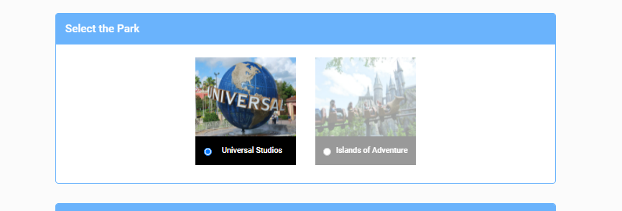

1. Can we please update this wording ”User not Registered. Please subscribe our list first.” To User not registered. Please subscribe to our free list”



1. When I selected 5/4 it says no ride for some reason. Is it because we have the crowd levels set to low?

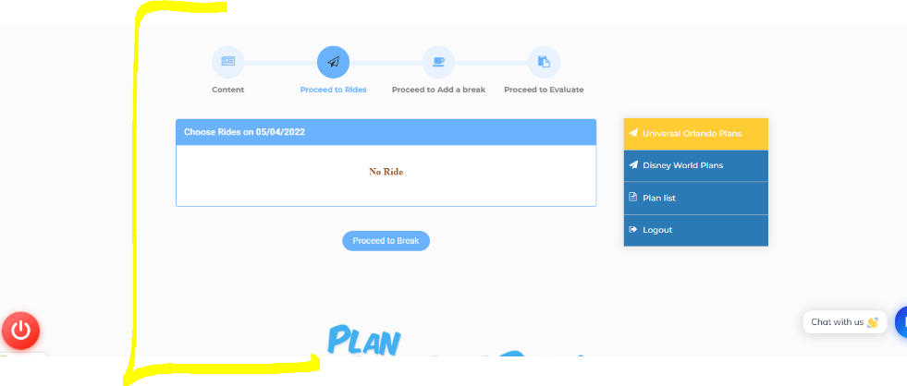  
8) Also the shows are not appearing when I select 5/13/2022 is this because that day is set to medium crowd level?

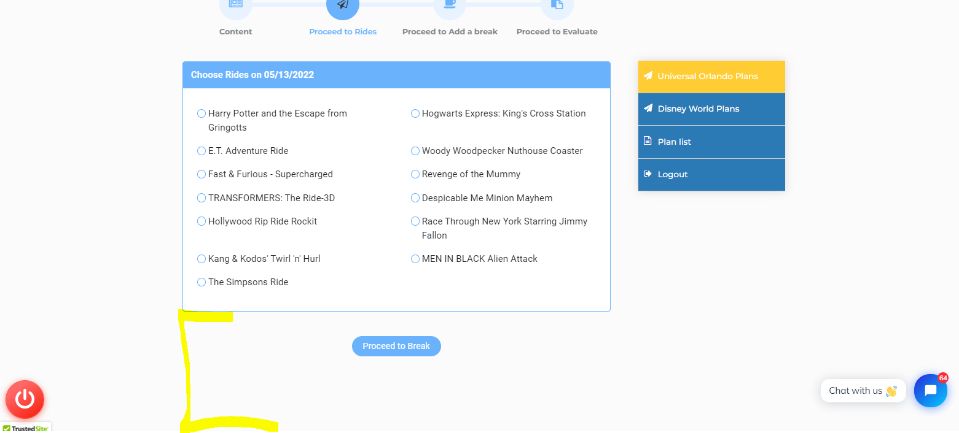

1. The rides and shows should always appear if they are set as active on the back end and should not have to do with the Low, Medium, or Heavy Crowds.

The Low Medium and Heavy Crowds should only be associated with the manage wait time data.

1. We are still have spacing issues with the wording on the email being sent out. We need to have a space between the sections like I have below:

Below is your custom park plan for your Universal Orlando trip! Please note that all wait times presented are predictions. It is always possible for crowds to vary, so we believe the best way to see Universal Orlando is to combine our park plans with the official Universal Orlando App!

This will allow you to see ride wait times in real time. You’ll also see that Universal Orlando has a lot to offer, and there might be some rides, character sightings, parades, and shows that you did not include in your plan which you might like to check out! Using the Universal Orlando app, you will be able to see all of the day’s show times, character sightings, and dining options at both parks.

Thank you again so much for supporting our small business and we hope you have an amazing vacation!

